Assignment 2
Q1. Differentiate between synthesized attributes and inherited attributes

S.NO | Synthesized Attributes | Inherited Attributes
1. | An attribute is said to be Synthesized attribute if its parse tree node value is determined by the attribute value at child nodes. | An attribute is said to be Inherited attribute if its parse tree node value is determined by the attribute value at parent and/or siblings node.
2. | The production must have non-terminal as its head. | The production must have non-terminal as a symbol in its body.
3. | A synthesized attribute at node n is defined only in terms of attribute values at the children of n itself. | An Inherited attribute at node n is defined only in terms of attribute values of n’s parent, n itself, and n’s siblings.
4. | It can be evaluated during a single bottom-up traversal of parse tree. | It can be evaluated during a single top-down and sideways traversal of parse tree.
5. | Synthesized attributes can be contained by both the terminals or non-terminals. | Inherited attributes can’t be contained by both, It is only contained by non-terminals.
6. | Synthesized attribute is used by both S-attributed SDT and L-attributed SDT. | Inherited attribute is used by only L-attributed SDT.
7. | 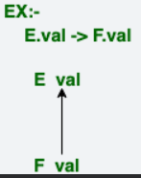 | 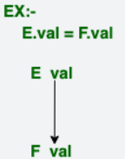

Q2. How Lex (flex) tool can be used to create Lexical analyzer? Explain with help of example

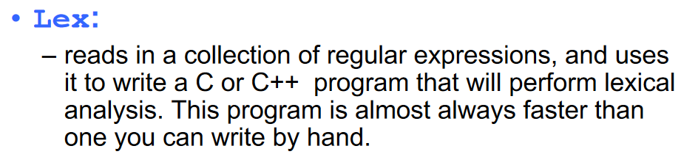
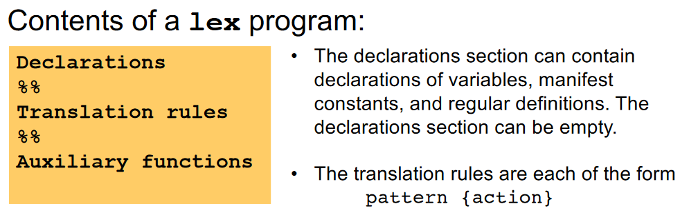

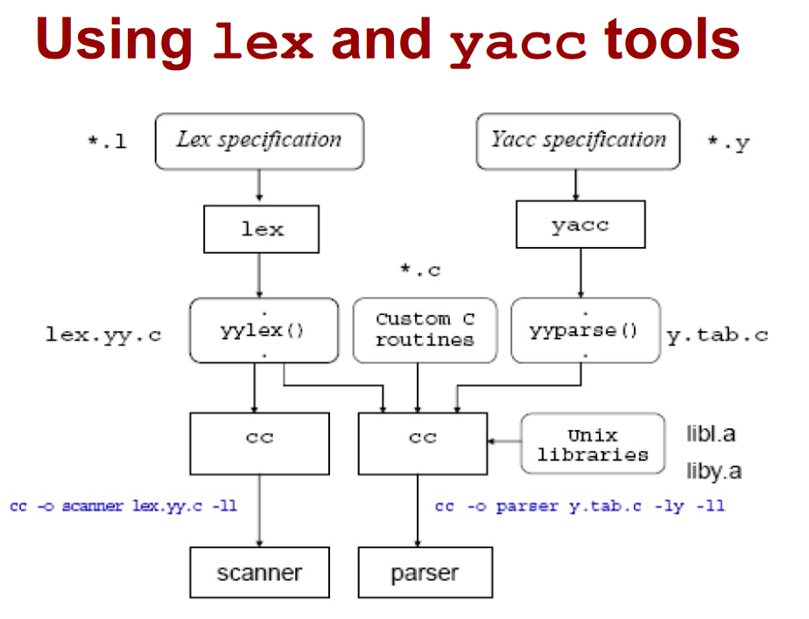

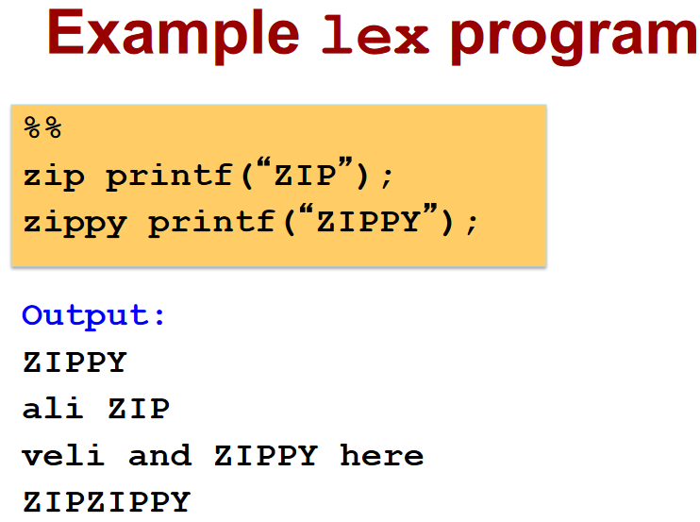

Q3. Define the following a) Topological Sort b) Dependency Graph c) Attribute d) Circular SDT

a) Topological sorting
for Directed Acyclic Graph (DAG) is a linear ordering of vertices such that for every directed edge u-v, vertex u comes before v in the ordering.
Note: Topological Sorting for a graph is not possible if the graph is not a DAG.

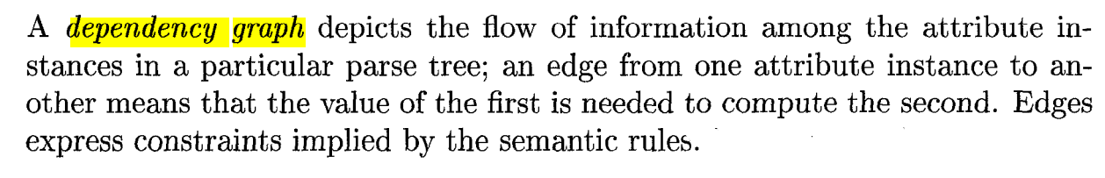
b)

c) Attribute Grammar
Attribute grammar is a special form of context-free grammar where some additional information (attributes) are appended to one or more of its non-terminals in order to provide context-sensitive information. Each attribute has well-defined domain of values, such as integer, float, character, string, and expressions.
Attribute grammar is a medium to provide semantics to the context-free grammar and it can help specify the syntax and semantics of a programming language. Attribute grammar (when viewed as a parse-tree) can pass values or information among the nodes of a tree

d) In a syntax-directed translation (SDT) scheme, circular SDT occurs when there’s a cycle in the dependency graph of attributes in a syntax tree, creating a circular dependency. This is problematic because it makes the attribute evaluation non-deterministic or impossible since each attribute relies on another in a cycle, preventing a clear order of evaluation.

